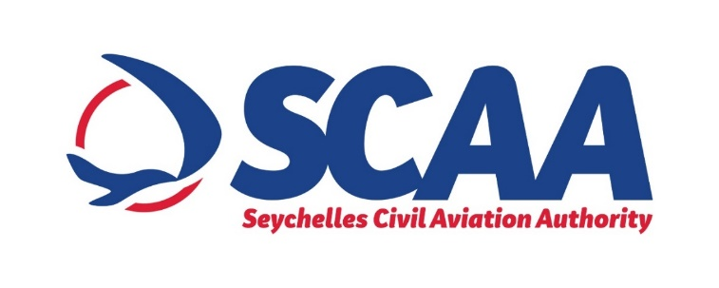

**PRESS NOTICE**

**PROCUREMENT OF CARGO X-RAY SCREENING MACHINE FOR SEYCHELLES INTERNATIONAL AIRPORT**

The SCAA wishes to inform that it will be procuring a Cargo X-ray Screening Machine for Seychelles International Airport under “Limited Bidding Method” under Section 61 2 (a) of the Public Procurement Act of 2008.

The purpose of this procurement is to replace the outdated cargo x-ray screening machine with a new one, which will put SCAA align with the ICAO guidelines.

The proposed shortlisted bidders are as follows:

1. Smith Detection
2. Rapsican
3. Alpha Airport
4. Advanced Logistics Systems
5. Mondotek Engineering Consultancy Services

Any potential bidder requiring any information on this Procurement or wishes to express interest in participating in same, may contact;

Mr. Gavin Domingue

Procurement Analyst

Tel: +248 4384213 (Monday to Friday, Office Hours from 0800hrs 1500hrs)

Email: procurement@scaa.sc

Any information sought or interest expressed should be done not later than

***Tuesday 14th September 2021 before 1500hrs.***

The SCAA reserves the right not to accept the lowest bid, reject any bid or cancel the bidding process at any time prior to the award of the contract without thereby incurring any liability to bidders.