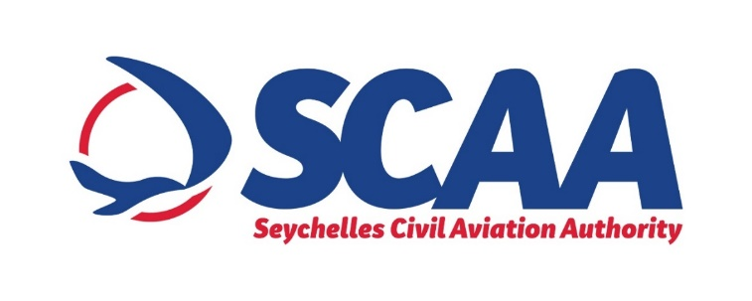

**PRESS NOTICE**

**Procurement of Uninterruptable Power Supply (UPS) for the Seychelles International Airport**

The SCAA wishes to inform that it will be procuring a new 20KW Scalable Uninterruptable Power Supply (UPS) through "Limited Bidding" method under Section 61 2 (a) of the Public Procurement Act of 2008.

The purpose of this procurement is to add a third source of power as a back-up support to the existing two. Hence, in the event of an emergency (i.e: fire or damage to the room) the back-up equipment will allow for the smooth and continuous operations without any major disruption.

The proposed shortlisted bidders are as follows:

1. Scomat (Mauritius)
2. OCEM (Italy)
3. Alpha Airport (France)
4. Efore (Finland)

Any potential bidder requiring information or wishes to express interest in participating this tender, may contact;

Ms Winnie Leon

Senior Procurement Officer

Tel: +248 4384024 or +248 527 252 (Monday to Friday, Office Hours from 0800hrs 1600hrs)

Email: [wleon@scaa.sc](mailto:wleon@scaa.sc)

Any information sought or interest expressed should be done not later than

***Friday 24th January 2020 before 1500hrs.***

Seychelles Civil Aviation Authority reserves the right not to accept the lowest or any other tender.