**LANDSCAPE AND WASTE MANAGEMENT AGENCY**

**INVITATION TO TENDER**

**PROCUREMENT OF 600 MUNICIPAL WASTE BINS (240 LITRES CAPACITY)**

The Landscape and Waste Management Agency (LWMA) is inviting tenderers for the Supply of **600 Municipal Waste Bins 240L.**

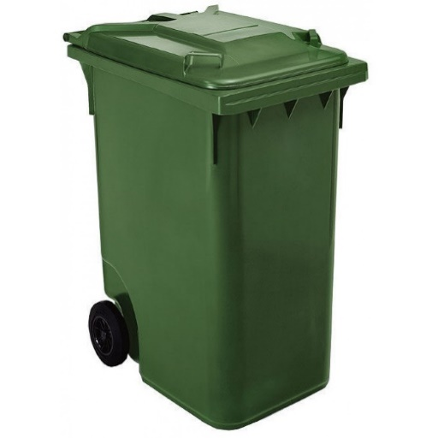

**Conditions**

* The Tender is open on equal terms to all locally Registered & licensed suppliers / company (retailers or importers),
* Bidders must satisfy the list of criteria and show proof of documentation in their submission (refer to bidding document)
* The successful supplier will have to ensure that delivery is made within Three (3) months from the Date of Award.
* All the above goods are to be transported to the LWMA Office English River
* All pricing should be in the local currency.

The Tender Dossiers can be obtained at the **Procurement Section, Landscape and Waste Management Agency (LWMA), Ex- English River Clinic, English River, Mahe, Seychelles** asof **Monday 06th September 2021 to Friday 10th September 2021 from 9:00am to 2:00pm,** upon payment of a non-refundable fee of **SR 150.00 each.** No bidding document shall be made available past this deadline period. **Bidders are allowed to inspect the tender document prior to purchase.**

TENDERS MUST BE SUBMITTED IN A SEALED ENVELOPE MARKED **“PROCUREMENT OF 600 MUNICIPAL WASTE BINS 240L – LWMA**” AND PLACED IN THE TENDER BOX LOCATED AT THE **NATIONAL TENDER BOARD (NTB) SECRETARAIT,1ST FLOOR, MAISON DE MAHE, VICTORIA,** BEFORE **10:00AM** **(SEYCHELLES TIME) ON MONDAY 27TH SEPTEMBER 2021.**

TENDERS WILL BE OPENED IMMEDIATELY AFTER CLOSING AT **10:00AM** ON **MONDAY 27TH SEPTEMBER** **2021** AT THE NATIONAL TENDER BOARD SECRETARAIT.

**LATE BIDS WILL BE REJECTED AND WILL BE RETURNED UNOPENED TO THE BIDDER.**

**Interested bidders can view this Bid notice on** [**www.ntb.sc**](http://www.ntb.sc) **and** [**www.pou.gov.sc**](http://www.pou.gov.sc)

**FOR ANY QUERIES, PLEASE CONTACT:**

**Ms. Christina Dora**

**Procurement Manager**

**Landscape and Waste Management Agency**

**Tel: 4 324334 / 4324836 (between 08.00a.m and 16.00p.m) or via e-mail:** [cdora@gov.sc](mailto:cdora@gov.sc)