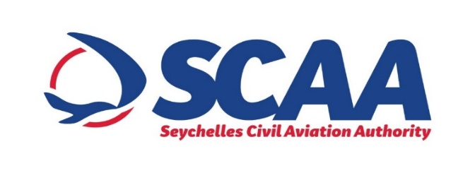

**INVITATION TO TENDER**

**REFURBISHMENT OF WOODEN STRUCTURES AT THE PRASLIN DOMESTIC AIRPORT**

The Seychelles Civil Aviation Authority (SCAA) would like to invite bidders for the *Refurbishment of Wooden Structures at the Praslin Domestic Airport*.

The objective of the procurement is to repair, clean and varnish existing structure.

**Eligibility**

* Tender is open to all local registered and licensed ***CLASS I & II*** contractors
* The successful bidder will have a delivery schedule of eight (8) weeks from date of contract award.

**Access to Tender Document**

*Tender document can be purchased m* ***Wednesday 07th to Tuesday 14th September 2021 from 0900hrs to 1500hrs*** *at the Procurement Unit, Seychelles Civil Aviation Authority, Pointe Larue.* *The closing date for obtaining the tender dossier is* ***Tuesday 14th September 2021 at 1500hrs.***

**NOTE:** The tender dossier is available at a non- refundable fee of SCR 300.00 to all interested bidder. Bidders may inspect the bidding document prior to purchase.

**Pre-Tender Site Visit**

A Pre-tender site visit has been scheduled for ***Wednesday 15th September 2021 at 1330hrs***at the Praslin Domestic Airport.

**Submission of Tenders**

Tenders must be submitted in a sealed envelope marked; ***“REFURBISHMENT OF WOODEN STRUCTURES AT THE PRASLIN DOMESTIC AIRPORT***” and placed in the tender box situated at the ***Praslin Domestic Airport, Grand Anse, Praslin*** ***OR*** at the ***National Tender Board***, ***Maison de Mahe, Victoria***, before ***1100HRS on Wednesday 29th September 2021*.**

**Tender Opening**

Tenders will be opened immediately after closing at on ***Wednesday 29th September 2021 at 1100hrs*** at the ***National Tender Board, Maison de Mahe, Victoria***.

**ANY BIDS RECEIVED AFTER THE DEADLINE WILL NOT BE ACCEPTED AND WILL BE RETURNED UNOPENED TO THE BIDDER**

For any enquiries please contact;

***Mr. Gavin Domingue***

***Procurement Analyst***

***Seychelles Civil Aviation Authority***

***Telephone: 4384213 or Email:*** [***procurement@scaa.sc***](mailto:procurement@scaa.sc).