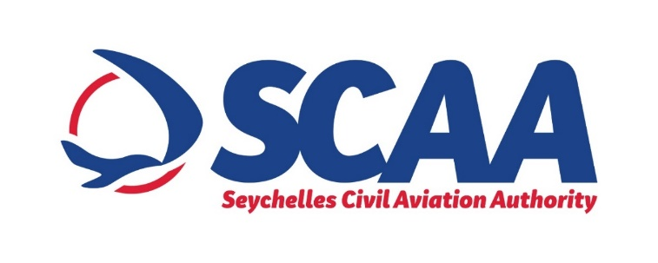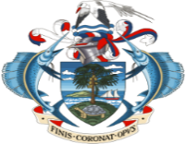

**INVITATION TO TENDER**

**PROCUREMENT OF WATER BOOSTER PUMP**

The **Seychelles Civil Aviation Authority (SCAA**) would like to invite bidders for the procurement of water booster pump.

The objective of the procurement is to have sufficient water pressure in the toilets and Restaurants at the Seychelles International Airport during dry season.

Conditions

* Tender is open to all local and International licensed companies
* The successful supplier will have to ensure that delivery is made within four (4) weeks from date of Award.

**Interested bidders are informed that bidding document can be obtain from the** Seychelles Civil Aviation Authority, Procurement Unit, Pointe Larue **as of Tuesday 27th July, 2021 to Monday 02nd July, 2021 from 10:00hrs to 3:00hrs or you can email us on** [**procurement@scaa.sc**](mailto:procurement@scaa.sc) **to get a copy of the Tender Documents.**

**No bidding document shall be made available past this deadline period.**

Bidders may inspect the bidding document before purchasing. Bidders can view this notice on

[www.pou.gov.sc](http://www.pou.gov.sc) or www.ntb.gov.sc

Tenders must be submitted in a sealed envelope marked **”Tender for Procurement of Water Booster Pump”** and deposited in the Tender Box Located at the **National Tender Board (NTB), 1st Floor Maison de Mahe, Victoria, Mahe , Seychelles and/or sent** via email [**NTBtenderbox@gov.sc**](mailto:NTBtenderbox@gov.sc)before **11:00hrs** **(Seychelles Time) on Wednesday 18th August 2021.**

Bids will be opened immediately after closing at **11:00hrs on Wednesday 18th August 2021** at the National Tender Board.

**LATE BIDS WILL BE REJECTED AND WILL BE RETURNED UNOPENED TO THE BIDDER.**

**FOR ANY QUERIES, PLEASE CONTACT:**

**Mrs Prisca Figaro, Procurement Unit Tel: 4384085 Email:** [**procurement@scaa.sc**](mailto:procurement@scaa.sc)