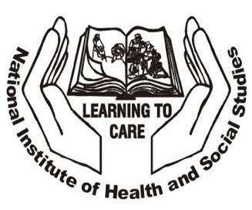

NATIONAL INSTITUTE OF HEALTH AND SOCIAL STUDIES

INVITATION TO TENDER

PROCUREMENT OF VEHICLE

The National Institute of Health and Social Studies (NIHSS) invites tenders for The Procurement of x1 Vehicle (16 Seater Mini Van).

Source of Finance: Government of Seychelles

Project Title: Procurement of x1 Vehicle (16 Seater Mini Van)

Eligibility: The following are eligible to tender on equal terms: All licensed
Motor Vehicle dealers operating in Seychelles.

Subject: The procurement of Vehicle is to be used for administration duties.

Period Delivery: Availability of stock for immediate purchase or three months from date of confirmation

Access to tender Dossier: The tender Dossier can be obtained at the reception of the NIHSS, North East Point, as of Friday 10th September 2021 at 9.00 am to 2.00 pm

Closing date for Dossier: The closing date for obtaining the tender Dossier is Friday 17th September 2021 at 2.00 pm.

Note: The tender documents are to be given to the interested bidders for free.

Submission of Tenders
TENDERS MUST BE SUBMITTED IN A SEALED ENVELOPE MARKED, “PROCUREMENT OF 1x VEHICLES”AND DEPOSITED IN THE TENDER BOX LOCATED AT THE NATIONAL TENDER BOARD (NTB) MAISON DE MAHE, VICTORIA BEFORE 10:30 AM ON MONDAY 04TH OCTOBER 2021.
TENDERS WILL BE OPENED IMMEDIATELY AFTER CLOSING AT 10:30 AM.

ONLY ONE BIDDERS OR ONE REPRESENTATIVE ARE WELCOME TO ATTEND THE TENDER OPENING SESSION.

Any bid received after the deadline will be returned unopened to the Bidder and will not be accepted.

Interested Contractors can also view this press notice on www.pou.gov.sc or www.ntb.gov.sc

All enquiries regarding the project please contact Mr. Ebrahim Mohamed Ali, Deputy Director, National Institute of Health and Social Studies, North East Point, Tel: 4242006, Email: eali@health.gov.sc

