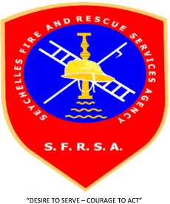

**SEYCHELLES FIRE AND RESCUE SERVICES AGENCY**

**BID NOTICE**

**PROCUREMENT OF MISCELLANEOUS FIRE FIGHTING EQUIPMENT**

The Seychelles Fire and Rescue Services Agency (SFRSA), wishes to inform all prospective Bidders, that the Agency will be undertaking the above mentioned procurement through Limited Bidding in line with Section 61 2 (a) of the Public Procurement Act 2008.

The proposed shortlisted bidders are as follows:

* Naffco
* Anglocco ltd
* Euclid infotech
* Cobra fire
* Marce firefighting technology

Any potential suppliers registered in Seychelles with a valid license requiring information on this procurement or wishing to participate in the same may contact the Seychelles Fire and Rescue Services Agency (SFRSA) based at Latanier Road, New Port, Victoria, Mahe by latest **Thursday 16th September, 2021.**

Any interest should be addressed to:

Mr. Jason Labrosse

Procurement Officer

Seychelles Fire and Rescue Services Agency

Latanier Road

Mahé

Seychelles

Tel: Off: 428 99 50 or Mob: 2813285

Email: [cfo@seychelles.net](mailto:cfo@seychelles.net)

Interested bidders may view this press notice on [www.ntb.sc](http://www.ntb.sc) or www.pou.gov.sc

All enquiries should be addressed to the Chief Fire Officer, Seychelles Fire and Rescue Services Agency (SFRSA), Latanier Road, P.O Box 1451, Victoria, Mahe, Seychelles,. Email: [cfo@seychelles.net](mailto:cfo@seychelles.net)