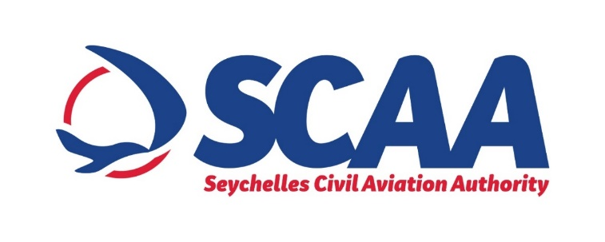

**PRESS NOTICE**

**PROCUREMENT OF 48VOLTS MODULAR BATTERY CHARGERS**

**FOR SEYCHELLES INTERNATIONAL AIRPORT**

The SCAA wishes to inform that it will be procuring 48volts Modular Battery Chargers for Seychelles International Airport under “Limited Bidding Method” under Section 61 2 (a) of the Public Procurement Act of 2008.

The purpose of this procurement is to supply a constant 48volts to key control devices within the electrical distribution systems as well as communication devices within the Airfield Ground Lighting System at the Seychelles International Airport

The proposed shortlisted bidders are as follows:

1. OCEM (Italy)
2. Alpha Airport (France)
3. Efore (Finland)
4. Engie Solutions – Ineo (France)
5. Taylor Smith Naval Services (Seychelles)

Any potential bidder requiring any information on this Procurement or wishes to express interest in participating in same, may contact;

Ms Prisca Figaro

Procurement Technician

Tel: +248 4384085 (Monday to Friday, Office Hours from 0800hrs 1600hrs)

Email: procurement@scaa.sc

Any information sought or interest expressed should be done not later than

***Wednesday 07th July 2021 before 1500hrs.***

The SCAA reserves the right not to accept the lowest bid, reject any bid or cancel the bidding process at any time prior to the award of the contract without thereby incurring any liability to bidders.