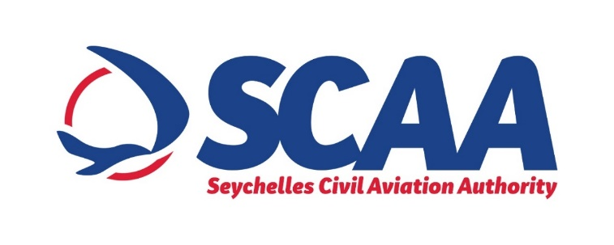

**PRESS NOTICE**

**PROCUREMENT OF PRIMARY AIRFIELD CABLE AND CONNECTORS FOR PRASLIN DOMESTIC TERMINAL**

The SCAA wishes to inform that it will be procuring airfield cable & Connectors for Praslin Domestic Terminal under “Limited Bidding Method” under Section 61 2 (a) of the Public Procurement Act of 2008.

The purpose of this procurement is to replace the existing cable and connectors which will enhance the power to its full and required capacity on the Praslin Domestic Terminal.

The proposed shortlisted bidders are as follows:

1. ADB Safegate (Belgium)
2. OCEM (Italy)
3. Alpha Airport (France)
4. Iavna (UK)
5. EastMint Marketing (Singapore)

Any potential bidder requiring any information on this Procurement or wishes to express interest in participating in same, may contact;

Ms Prisca Figaro

Procurement Technician

Tel: +248 4384085 (Monday to Friday, Office Hours from 0800hrs 1600hrs)

Email: procurement@scaa.sc

Any information sought or interest expressed should be done not later than

***Wednesday 07th July before 1500hrs.***

The SCAA reserves the right not to accept the lowest bid, reject any bid or cancel the bidding process at any time prior to the award of the contract without thereby incurring any liability to bidders.