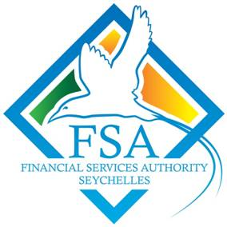

**INVITATION TO TENDER**

**TENDER FOR THE PROCUREMENT OF MICROSOFT EXCHANGE CLOUD LICENSES.**

The Financial Services Authority (FSA) is inviting tenders for the Procurement of Microsoft Exchange Cloud Licenses (Exchange Online Plan 1).

**Conditions:**

* The tender is opened to all locally registered and licensed service providers that have been certified as a Microsoft reseller;
* The bidders should have experience in supplying Microsoft Products to Government Organisations/Departments or private companies for the last five years;
* All pricing should be provided in Seychelles rupees (SR) Only;
* Specifications are included in Appendix IV of the Instruction to Bidders.

The tender documents can be obtained from the Financial Services Agency (FSA) Reception Office, Bois de Rose, Avenue, Roche Caiman, Mahe, Seychelles or by requesting a copy of the tender document electronically by emailing the Procurement Manager at the Email address specified below as from **Tuesday 14th September, 2021 between 8.30 a.m. to 3 p.m.** The closing date for the collection of tender’s dossier shall **Tuesday 21st September, 2021 at 03.00 p.m**.

TENDERS MUST BE SUBMITTED IN A SEALED ENVELOPE MARKED **“*PROCUREMENT OF MICROSOFT EXCHANGE CLOUD LICENSES (EXCHANGE ONLINE PLAN 1)*”** AND BE PLACED IN THE TENDER BOX SITUATED AT THE NATIONAL TENDER BOARD (NTB), FIRST FLOOR, MAISON DE MAHE, VICTORIA, BEFORE **THURSDAY 30TH SEPTEMBER, 2021 AT 10.00 A.M**. TENDERS WILL BE OPENED IMMEDIATELY AFTER CLOSING AT **10:00 A.M**. LATE BIDS WILL BE REJECTED AND RETURNED UNOPENED TO THE BIDDER.

**All enquiries should be addressed to:**

**Mr. Dereck Volcy**

**Procurement Manager**

**Financial Services Authority**

**Bois De Rose Avenue**

**Mahe, Seychelles**

**Tel: 4 38 08 00/2 63 69 41**

**Email:** [dereck@fsaseychelles.sc](mailto:dereck@fsaseychelles.sc)