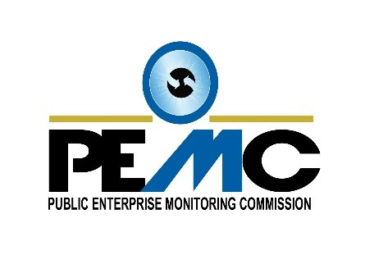

**BID NOTICE**

**PROCUREMENT OF CONSULTANCY SERVICES FOR THE DEVELOPMENT OF A FINANCIAL AND FISCAL RISK MONITORING SYSTEM FOR THE PUBLIC ENTERPRISE MONITORING COMMISSION.**

The Public Enterprise Monitoring Commission (PEMC) wishes to inform interested parties that it will be undertaking the procurement of consultancy services for the **development of a Financial and Fiscal Risk Monitoring System for oversight of the SOE (State-Owned Enterprises) sector** using the Limited Bidding Method under Section 62 (2) (a) of the Public Procurement Act 2008.

This is on the grounds of limited number of qualified service providers with the following credentials to undertake the service as per specifications:

* Experience in developing automated systems for data collection and consolidation
* Experience of working with SOEs, strong background in Financial and Fiscal Risk analysis and management of the sector
* Experience in working on SOE external and internal reporting frameworks and systems
* Experience and skills in data analysis
* Ability to provide trainings

The proposed shortlisted bidders are as follows:

1. Ms. Mathilde Ravanel – Vassy
2. Mr. Fatih Kuz
3. Drs. Eline van der Linden

Any potential bidder requiring any information on this procurement or wishing to participate in the procurement and has the above credentials may contact the **Senior Business Analyst** during working hours on office contact number Tel: 4303490 or Mobile Tel: 2606027 or email [meryl@pemc.sc](mailto:meryl@pemc.sc), at Public Enterprise Monitoring Commission based at Sunshine House, P. O Box 593, Providence Industrial Estate not later than **Friday 18th June 2021.**

Bidders may view this notice on [www.pou.gov.sc](http://www.pou.gov.sc) or [www.ntb.gov.sc](http://www.ntb.gov.sc).