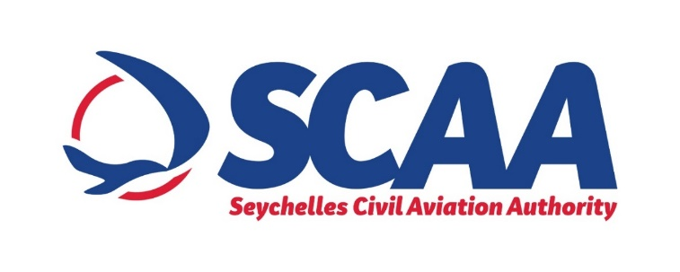

**PRESS NOTICE**

**PROCUREMENT OF PILLAR FIRE HYDRANTS AND ACCESSORIES FOR SEYCHELLES INTERNATIONAL AIRPORT (SIA)**

The Seychelles Civil Aviation Authority (SCAA) wishes to inform that it will be procuring Fire Hydrants and Accessories for Seychelles International Airport through "Limited Bidding Method” under Section 61 2 (a) of the Public Procurement Act of 2008.

The objective of the procurement is to guarantee that SCAA have sufficient water supply which shall be used as backup water supply for fire tenders dealing with any fire incident breakout on landside of the International Terminal Building, Domestic Terminal and Offices.

The proposed shortlisted bidders are as follows:

1. Marce Fire Fighting Technology (MUR)
2. Rosenbauer International AG (Austria)
3. Bristol Fire Engineering (UAE)
4. NAFFCO FZCO (UAE)
5. Millbro Manufacturing Pty (SA)

Any potential bidder requiring any information on this Procurement or wishes to express interest in participating in same, may contact;

Ms Winnie Leon

Senior Procurement Officer

Tel: +248 4384024 (Monday to Friday, Office Hours from 0800hrs 1600hrs)

Email: [wleon@scaa.sc](mailto:wleon@scaa.sc)

Any information sought or interest expressed should be done not later than

***Friday 11th June 2021 before 1500hrs.***

The SCAA reserves the right not to accept the lowest bid, reject any bid or cancel the bidding process at any time prior to the award of the contract without thereby incurring any liability to bidders.